115-32-10250-2077 Klehini River Correction
Water body name: Klehini River Survey date: 9/9/2015
Water body number: 115-32-10250-2077 Species & Lifestage: CHp,COp,Kp,Sp,CTp,DVp
Watershed: Klehini river
MTR: C028S054E Quad: Skagway B-4
Findings: The mapped route of the Klehini River no longer reflects the stream’s actual course.
Recommendations: Since subsequent nominations rely on an accurate mainstem route please correct the stream’s course, as shown in Figure 1.
Nomination number: Pending
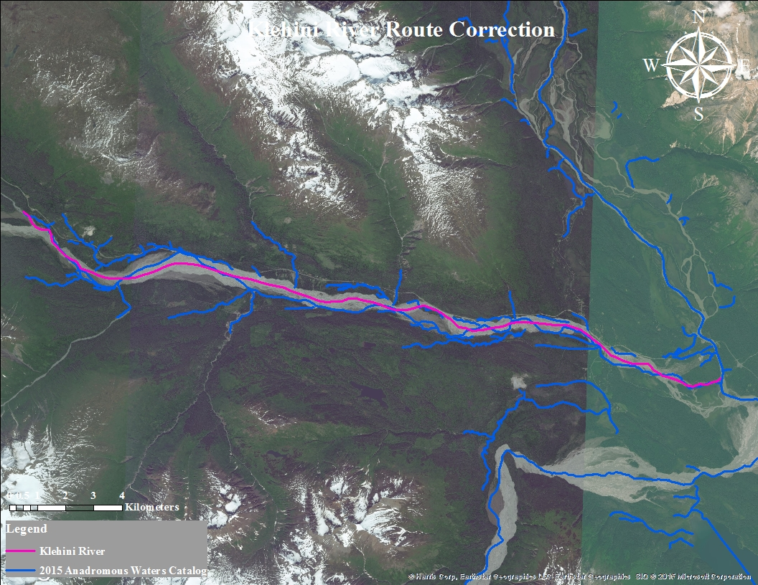
Figure 1.–Klehini River route correction map.

